# Chemicals in Cosmetics Report

***Introduction***

The California Safe Cosmetics Program (CSCP) is a regulatory initiative by the California Department of Public Health (CDPH) to collect and disseminate information about hazardous and potentially hazardous ingredients in cosmetic products sold within the state. The primary objective of the CSCP is to ensure transparency and public awareness regarding the potential risks associated with certain ingredients known or suspected to cause cancer, birth defects, or other developmental or reproductive harm.

***Task***

The task involves analyzing the data reported to the CSCP by cosmetic product manufacturers, packers, and distributors. This data encompasses various aspects of the products, including label names, company information, brand names, product categories, Chemical Abstracts Service (CAS) registry numbers, chemical ingredient names, reported chemical counts, and relevant dates such as initial reporting, discontinuation, or reformulation.

The analysis should aim to provide insights into the following areas:

1. Identifying and counting distinct product names, companies, brands, categories, sub-categories, CAS numbers, chemical IDs, and chemical names.

2. Filtering and quantifying products with specific characteristics, such as non-blank CSF values, discontinued products, or products containing certain chemicals.

3. Calculate the time differences between the initial and most recent reporting dates, expressed in several days.

4. Counting chemicals reported within specific date ranges or periods.

5. Creating time intelligence reports and visualizations to analyze trends in chemical reporting over time.

6. Grouping and summarizing data by categories, sub-categories, companies, or brands.

7. Calculating year-over-year changes in the number of reported chemicals.

8. Develop interactive reports with slicers and filters to enable user-driven data exploration based on different criteria.

The analysis should provide valuable insights into the reporting practices, product compositions, and potential risks associated with cosmetic products sold in California.

***Action***

The data provided was relatively clean. I checked for blank rows and checked to ensure that each column had the appropriate data type. After this was done, I used DAX functions to create measures to get insight during the analysis.

***Exploratory Data Analysis***

* Data profiling: this involved understanding the data’s structure and content by examining its columns and data types. I checked for missing values, duplicates, and outliers in specific columns, and identified potential data quality issues or inconsistencies in various columns.
* Univariate analysis: I calculated summary statistics for specific columns, created measures for categorical columns to understand their distribution, and visualized these columns using cards.
* I compared categorical columns analyzing relationships between date columns and other variables using area charts.
* I used a decomposition tree to visualize hierarchical relationships between categorical columns like “Primary Category”, “Sub-Category”, “Product Name”, “Chemical Count”, and “Company Name”.
* I created time series visualizations like line charts or area charts to analyze trends over time for columns like “Initial Date Reported”, “Most Recent Date Reported”, “Chemical Created Date”, “Chemical Updated Date”, and “Chemical Date Removed”.
* In the analysis report, tables were constructed to gain insights into the most frequently reported chemicals, products, and companies. These tables serve as a valuable tool for identifying trends and patterns in the reported data.

***Results***

* This analysis, spanning from 2009 to 2020, encompasses 114.64K chemical reports. These chemicals were identified across 13 distinct product categories. It was found that 635 companies utilized 58.08K chemicals to produce approximately 33.45K products. Notably, the use of 8.85K chemicals was discontinued during this period.
* 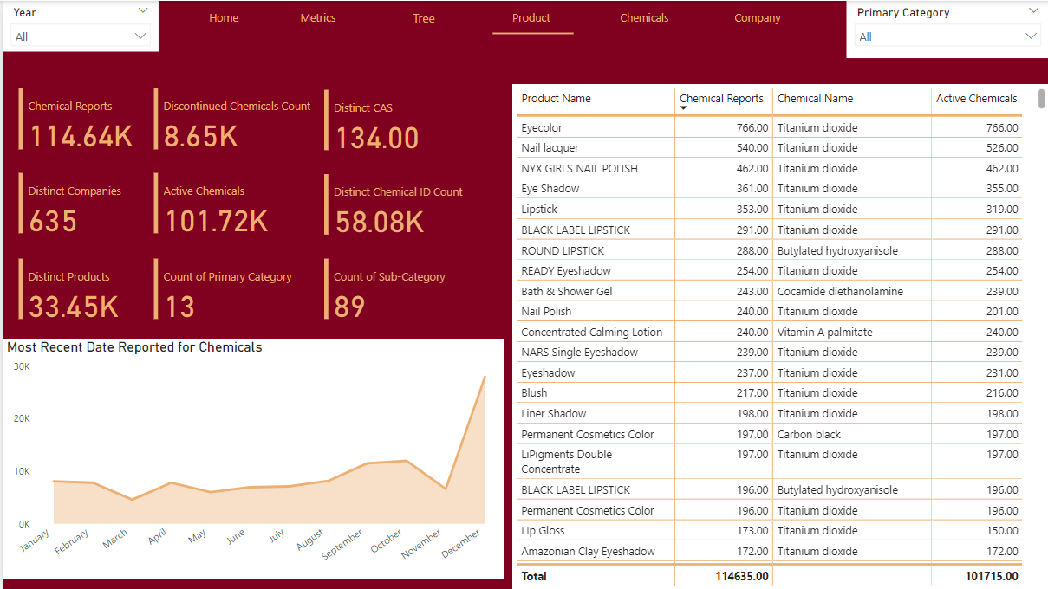
* In this analytical report, it was observed that Titanium dioxide was the most frequently reported chemical. Specifically, it accounted for 93.48K reports, constituting 81.55% of all chemical reports.
* 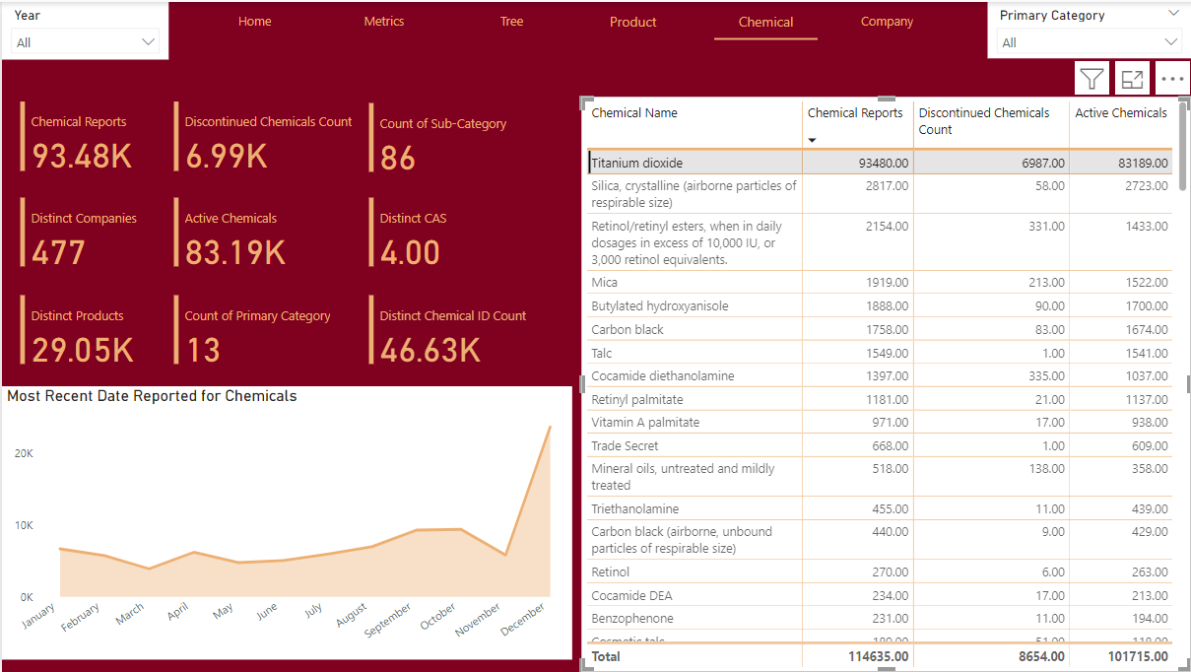
* The analysis report encompasses a total of 33.45K products, which are systematically classified into 13 main categories and further subdivided into 89 sub-categories. Upon examination, it is observed that the products with the highest number of reports include Eyecolor (766 reports), Nail lacquer (540 reports), NYX GIRLS NAIL POLISH (462 reports), Eye shadow (361 reports), and Lipstick (353 reports).
* 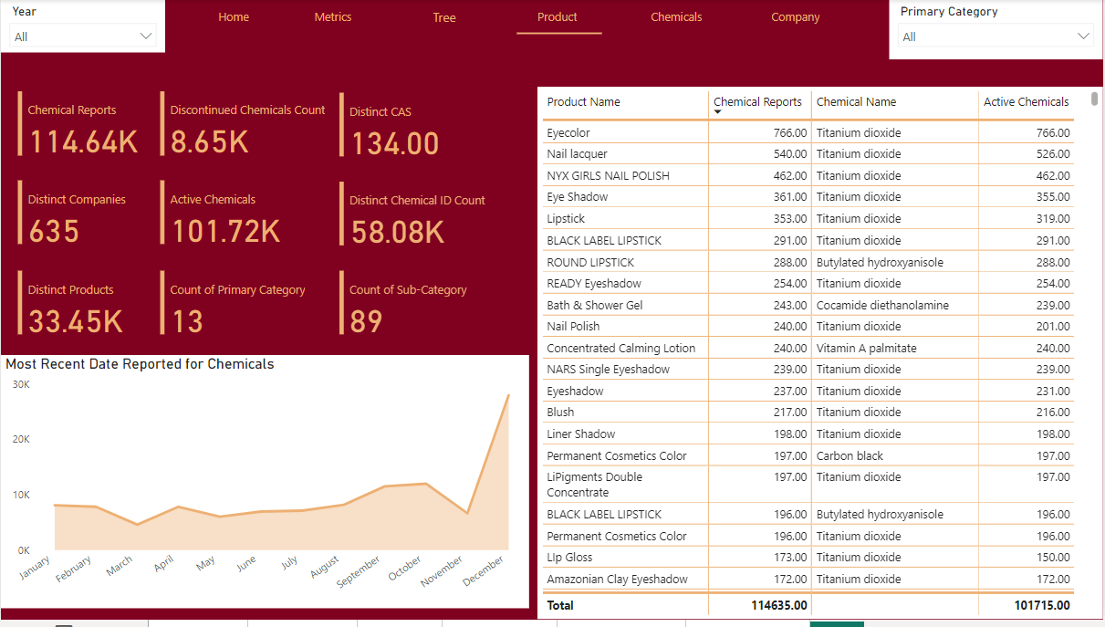
* In the analysis conducted, a total of 635 companies were examined. Among these, the companies with the highest number of chemical reports were L’Oreal USA with 5,747 reports, S+ with 5,165 reports, Coty with 5,162 reports, Revlon Consumer Product Corporation with 4,341 reports, and Bare Escentuals Beauty Inc with 3,828 reports. These companies stood out as the most reported within the analysis.
* 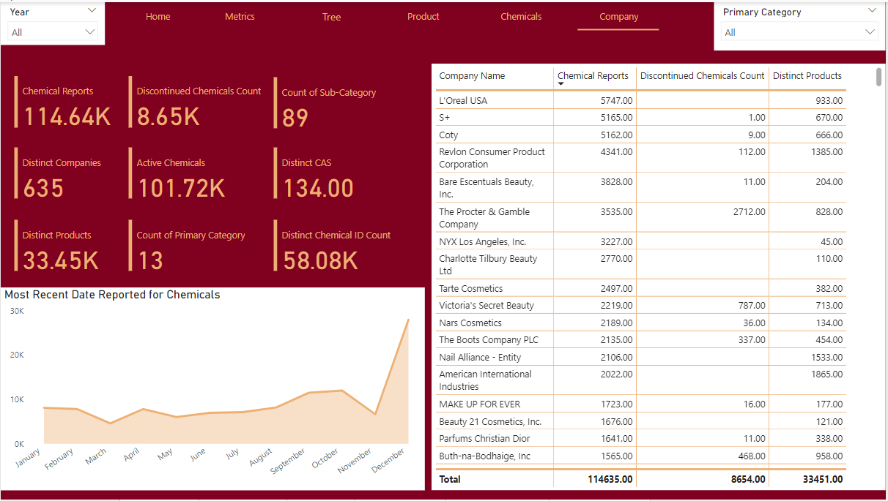
* In the conducted analysis, the companies with the highest number of reported products were identified. American International Industries topped the list with 1,675 products, followed by Nail Alliance – Entity with 1,414 products. Revlon Consumer Product Corporation reported 1,362 products, AMOREPACIFIC US INC. had 1,045 products, and L’Oreal USA reported 933 products. These companies were the major contributors in terms of product reporting.

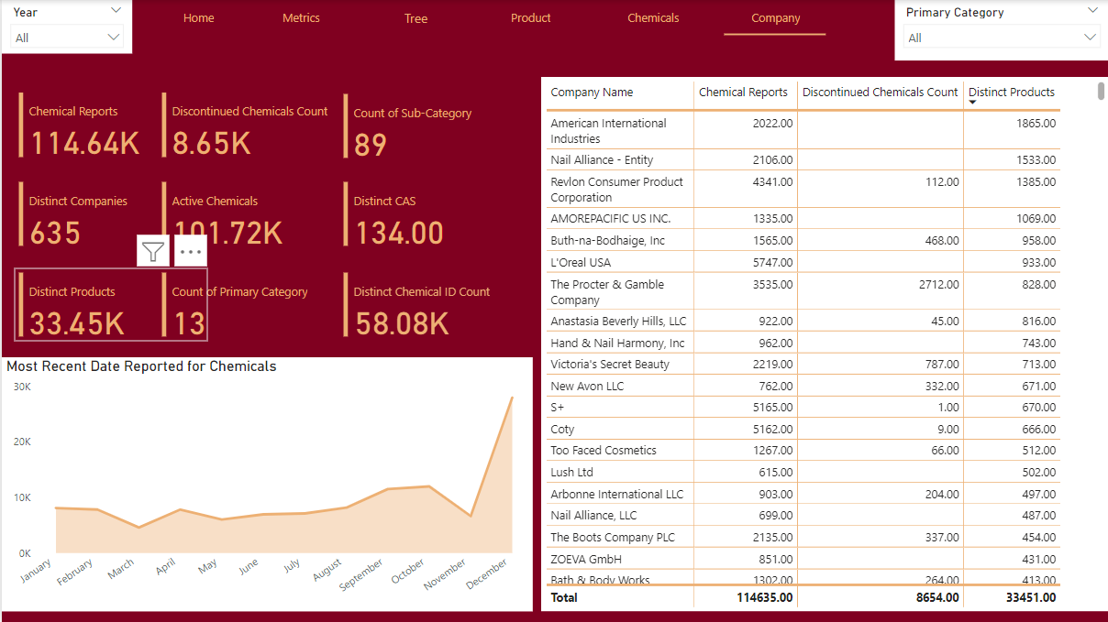

* The analysis report indicates that The Procter & Gamble Company leads the list of companies with the most discontinued chemicals, accounting for 2.7K. This is followed by Victoria’s Secret Beauty with 787, MAESA LLC with 589, Buth-na-Bodhaige Inc. with 468, and The Boots Company Plc with 337 discontinued chemicals. These companies represent the highest number of discontinued chemicals in the industry.

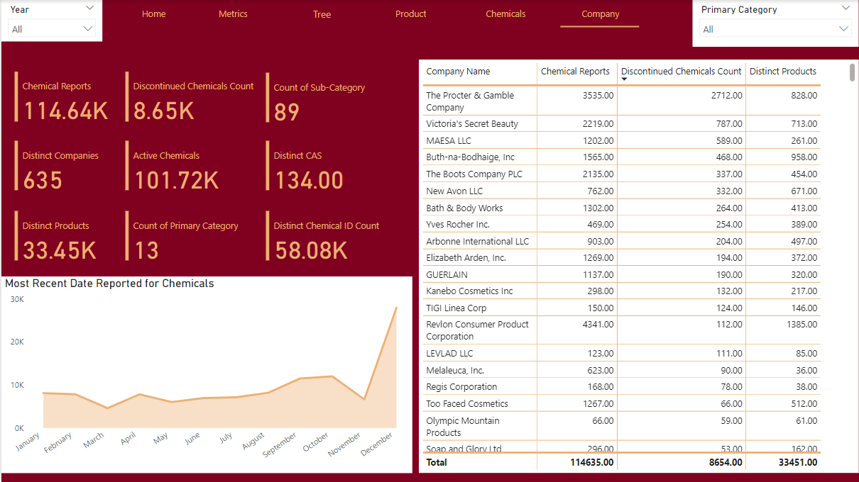

* The analysis of chemical reporting trends from 2009 to 2020 reveals significant fluctuations. The highest number of reports was in 2009 with 30.68k, followed by a sharp decline to 14.78k in 2010 and continued to decrease until 2012. A resurgence was observed from 2013 to 2019, peaking at 13.88k reports in 2019. However, 2020 saw a drastic drop to 2.58k reports. This data indicates a general downward trend in chemical reporting over the examined period.
* From 2009 to 2020, titanium dioxide consistently topped the annual chemical analysis reports. In 2009, it had 25,308 reports, followed by butylated hydroxyanisole (1562) and retinol (939). In 2010, retinol (782) and cocamide diethanolamine (539) trailed titanium dioxide (12,133). In 2011, retinol (400) and retinyl palmitate (110) followed titanium dioxide (3671). Triethanolamine (151) and vitamin A palmitate (65) were next in 2012. In 2013, vitamin A palmitate (454) and retinyl palmitate (299) followed titanium dioxide (4749). Carbon black and mica emerged in 2014 and 2015, while benzophenone appeared in 2016. Silica became prominent in 2017, and talc appeared in 2018 and 2020. Despite fluctuations in the other two chemicals, titanium dioxide consistently led each year, although its reports significantly dropped to 1805 in 2020.

***Recommendations***

* Maintain an up-to-date and complete inventory of all chemicals used in cosmetic products, including their chemical names, CAS numbers, and hazard classifications.
* Develop a strategy to prioritize the substitution or elimination of high-risk chemicals with safer alternatives, focusing on the most hazardous substances first.
* Continuous monitoring and improvement: Implement a system for continuous monitoring and improvement, regularly reviewing and updating the chemical inventory, hazard assessments, and risk management strategies to ensure alignment with the latest scientific evidence and regulatory requirements.
* Engage in collaborative efforts with industry partners, research institutions, and regulatory bodies to share best practices, exchange information, and develop industry-wide standards for managing high-risk chemicals.
* Allocate resources for research and development aimed at finding safer and more sustainable alternatives to high-risk chemicals, as well as innovative product formulations and manufacturing processes
* Increase transparency and open communication with stakeholders, including regulatory authorities, industry associations, and consumer groups, regarding the presence and management of high-risk chemicals in cosmetic products.
* Improve product labeling to clearly disclose the presence of high-risk chemicals, their potential hazards, and appropriate handling and disposal instructions.
* Develop a strategy to prioritize the substitution or elimination of high-risk chemicals with safer alternatives, focusing on the most hazardous substances first.